MODERN TIMES · 1936 / LOOK CLOSELY

Who sets the pace?
Name __________________________________ Date __________________
01 Notice before you explain
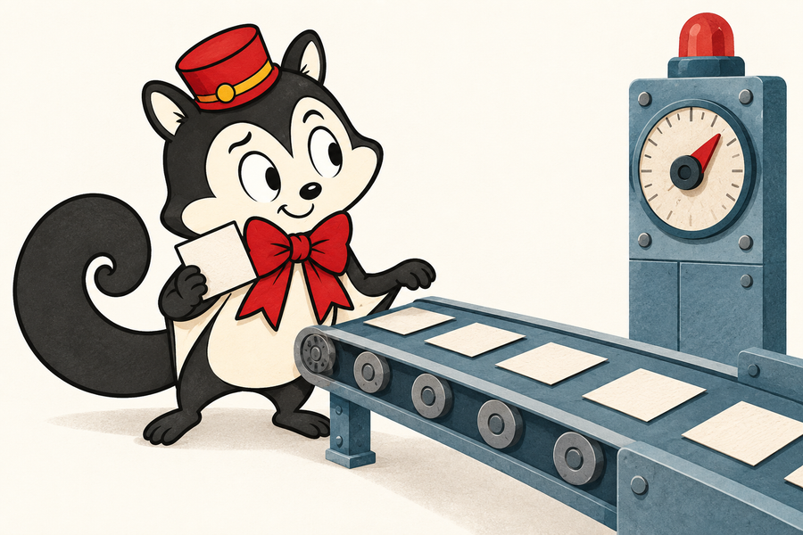 | Look at Momo’s workshop. Observe two visible details. Interpret what they suggest.  Discuss: can a still picture tell you the speed or who controls it?

Two visible details:

I think they suggest ... because ...

02 Follow the factory rhythm
Choose two conveyor-belt moments. Separate what happens from what you think it means.
A detail I saw or heard | What it suggests about the pace

Who can change the pace? Support your answer with one detail.

MODERN TIMES · 1936 / TEST AND REDESIGN

A machine for whom?
Follow one promise through the feeding machine test. Name the person affected.
03 Trace the test
Promise: what should improve? | → | Result: what happens in the test? | → | Human need: what does the person need?

04 Change one part
Sketch or describe one change to the machine or the way work is organised.

My change meets the person's need by ...

A trade-off: what could it cost, slow down or make harder?

BEFORE YOU LEAVE  Who should be able to change the pace of work? Give a reason using one detail from the film. | 

My view, with evidence:

MODERN TIMES · 1936 / PREPARE AND GUIDE

Teaching the factory scenes
Ages 12–16. Plan 45 minutes of activity plus viewing and replay time.
Students connect observations to interpretations, examine physical needs at work, and explain an effect of movement or sound.
Prepare the viewing
Cue the conveyor belt routine, including a change in pace, and the feeding machine pitch and test. Use scene cues because editions differ. The full film is not required.
Introduce this 1936 Great Depression comedy. Examine the factory as a comic construction, not a complete record of working conditions. Preview excerpts and arrange film access.
Momo’s workshop is an imagined scene for observation practice. For the optional sound discussion, cue the later café song; use a separate discussion or part of the redesign time.
A 45-minute activity
Time | Activity
5 min | Picture warm-up: distinguish a visible detail from its interpretation.
12 min | Conveyor evidence in pairs: compare two readings of one detail.
10 min | Trace the feeding machine's promise, result and human need.
12 min | Redesign one part; explain the need and a plausible trade-off.
6 min | Write the exit response; share a claim made more precise by evidence.

ASK THE CLASS  What would you need to test before calling your change an improvement? Let partners point, sketch or discuss before writing. | 

Offer “I noticed…” and “This could suggest…”. Students can dictate. Describe action aloud when needed; use captions and identify heard voices.

MODERN TIMES · 1936 / DISCUSS AND ASSESS

Reward the reasoning
Conveyor: repeated gestures may suggest that the job sets the body's rhythm. Students might instead emphasise skill, coordination or an interruption's comic timing. Ask for the exact gesture or sound.
Feeding machine: the pitch promises more working time; the test makes eating difficult. A stop control, slower setting or proper break could address a need, with costs or lost production time as possible trade-offs. Accept other workable proposals.
Optional sound: the boss speaks through a screen; the sales pitch is recorded. Later, the Tramp sings invented words. Students may contrast authority and play, or fixed instructions and improvisation, using visible and audible details.
Four assessment criteria
Look for | A successful response
Specific evidence | Identifies a movement, object, sound or event.
Reasoning | Links detail to interpretation; distinguishes a guess from an observation.
Workable change | Addresses a human need and recognises a plausible trade-off.
Attention to film | Explains an effect of performance, rhythm or sound.

Optional scoring: 0 = not yet shown; 1 = partly explained; 2 = clearly supported. Four criteria, 8 points.
LOOK AGAIN  When readings differ, return to the detail. An answer may value efficiency and still question who controls it. Judge the reasoning, not agreement with a sample. | 

Sources and use
Chaplin official site — Filming Modern Times: scenes, production and voices.
MoMA — Charles Chaplin's Modern Times: physical needs, performance and sound.
Ohio State History Teaching Institute — The Automobile: classroom use of factory scenes.
MIT OpenCourseWare — Capital, Labor, and the Standardization of Work: teaching context.
Accessed 14 September 2026. Activities written independently by Monocurator.
Free to print, share and adapt this material, including its Momo illustrations, for your classes. Arrange film access and screening permission separately.

